|  |  |  |
| --- | --- | --- |
|  | TABLE OF CONTENTS |  |
|  | Acknowledgement | 3 |
|  | Abstract | 4 |
|  | List of Tables | 5 |
|  | List of Figures | 6 |
| Chapter 1 | **Introduction** |  |
|  | 1.1 Project Profile | 7 |
| Chapter 2 | **Requirement Specification** |  |
|  | 2.1 Existing System | 8 |
|  | 2.2 Need For New System | 9 |
|  | 2.3 Time line Chart | 10 |
| Chapter 3 | **Introduction** |  |
|  | 3.1.1 Purpose | 11 |
|  | 3.1.2 Scope | 11 |
|  | **3.2 General Description** |  |
|  | 3.2.1 Functional Description | 12 |
|  | 3.2.2 User Characteristics | 12 |
| Chapter 4 | **Hardware & Software Specification** |  |
|  | 4.1 Hardware Requirement | 13 |
|  | 4.2 Software Requirement | 14 |
| Chapter 5 | **Detailed Design** |  |
|  | 5.1 Data Dictionary | 15 |
|  | 5.2 Entity Relationship Diagram | 19 |
|  | 5.3 UML Diagrams |  |
|  | 5.3.1 USE CASE DIAGRAM | 20 |
|  | 5.3.2 CLASS DIAGRAM | 23 |
|  | 5.3.3 SEQUENCE DIAGRAM | 24 |
|  | 5.3.4 ACTIVITY DIAGRAM | 27 |
| Chapter 6 | **Input & Output Designing** |  |
|  | 6.1 Admin Side Design | 31 |
|  | 6.2 user Side Design | 34 |

|  |  |  |
| --- | --- | --- |
| Chapter 7 | Testing & Results |  |
|  | 7.1 Introduction | 42 |
|  | 7.2 Test Cases | 43 |
| Chapter 8 | **Limitations & Future Scope** |  |
|  | 8.1 Limitations | 49 |
|  | 8.2 Future Scope | 49 |
| Chapter 9 | **Conclusion** | 50 |
| Chapter 10 | **References** | 51 |

**ACKNOWLEDGMENT**

We would like to thank everyone who helped in our project. We have this great

opportunity to express our deep gratitude to our Mentor Mr. of SPCE

MCA College, Visnagar for his timely and valuable guidance as well as for responding

faith and confidence on us throughout the duration of our project whenever needed.

Lastly it is our great pleasure to acknowledge our obligation to all those who were

directly or indirectly involve in making our partial project a successful piece of work.

Your Faithfully,

Krunal Bhavsar.

Guarang Parmar.

**ABSTRACT**

We provide information about freelancers and freelancing services.

**LIST OF TABLE**

|  |  |  |
| --- | --- | --- |
| Table No | Table Name | Page No |
| Table 1 | users (Admin/Client/Freelancer) |  |
| Table 2 | feedbacks |  |
| Table 3 | projects |  |
| Table 4 | requests |  |

**LIST OF FIGURES**

|  |  |  |
| --- | --- | --- |
| Figure No | Figure Name | Page No |
| Figure 1 | Entity Relationship Diagram |  |
| Figure 2 | Use Case Diagram |  |
| Figure 3 | Class Diagram |  |
| Figure 4 | Sequence Diagram |  |
| Figure 5 | Activity Diagram |  |

1. **INTRODUCTION**

|  |  |
| --- | --- |
| 1.1 Project Profile | |
| Project Title | **CODEWORK FREELANCER MANAGEMENT SYSTEM** |
| Project Definition | We provide information about freelancers and freelancing services |
| Internal Project Guide | Prof. Idrish I. Sandhi |
| Team Size | 2 |
| Team Member | 1.Krunal Bhavsar  2. Gaurang Parmar |
| Application Server | PHP |
| Front End | Html, css, JavaScript |
| Using Framework | Core PHP |
| Back End | My Sql 5.0 |
| Report Generation Tool | MS Word 2016  MS PowerPoint 2016 |
| Project Duration | 4 months |

**2.REQUIREMENT SPECIFICATION**

**2.1 Existing System:**

* Time Consuming
* The current website takes more money as commotions.
* In existing system, mostly website focus on clients because they spends money, but there are less facilities for freelancer like it is not easy to find first project for freelancer but clients get there freelancer very easily.

**2.2 Need for New System**

* Various freelancer can be found for different type of website development and designing work.
* Client can post project and choose a best freelancer from all of list.
* Browse freelancer profiles, compare proposals and select the best one, award your project and your freelancer goes to work.
* Pay when you are satisfied!
* Codework has no access fees, subscriptions, monthly fees or annual fees. There are no fees to post a project or set up a user account. Employer commissions and upgrade fees are also waived for volume customers.
* Freelancers get there first project easily according to their experience and level of learned skills.

**2.3 Time Line Chart**

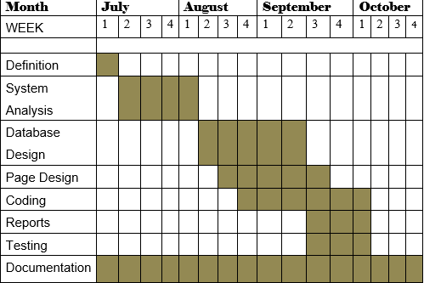

**3.FUNCTIONAL SPECIFICATION**

**3.1 Introduction**

**3.1.1. Purpose**

This website is used to provide platform for client and freelancer, where client can post a project and freelancer get job to do project.

**3.1.2. Scope**

**Admin:-**

* + Login
  + Manage clients
  + Manage freelancer
  + View all projects
* **user:-**
  + Register
  + Login
  + Post Project
  + View All Project
  + Request for project

**3.2 General Description**

**3.2.1. Functional Description**

* **ADMIN:-**

View, insert, update, or delete record of admin.

* **USER:-**

View, insert, update, or delete record of any Project.

**3.2.2. User Characteristics**

**Admin:-**

Admin is a top level person who is responsible for that site management and has keen watch on the site movements. Admin can manage all clients, freelancer and projects.

**User:-**

User is second level person who can Search and view Projects and post projects. It can manage project request.

**4.HARDWARE & SOFTWARE SPECIFICATION**

**4.1 Hardware Requirement:-**

* PROCESSOR : Intel Dual Core
* RAM : 2GB(recommended)
* HARD-DISK : 256GB(recommended)
* WINDOWS : WINDOWS 10

**4.2 Software Requirement:-**

* FRONT END TOOL : php 7.4
* BACK END TOOL : MySQL 5.0
* CODE EDITOR : VS(visual studio) code editor
* OTHER TOOLS : MS Word 2016 MS PowerPoint 2016

**5. Detailed Design**

**5.1 Data Dictionary**

**1)** **users (Admin/Client/Freelancer)**

Table name: auth_user

Primary key: id

Foreign key :

|  |  |  |  |  |  |
| --- | --- | --- | --- | --- | --- |
| SR.NO | Field Type | Data Type | Size | Constraints | Description |
| 1 | Id | Int | 11 | Primary key | User id |
| 2 | Name | Varchar | 30 | Not null | User name |
| 3 | Email | Varchar | 30 | Unique key | User email |
| 4 | Password | Varchar | 20 | Not null | User password |
| 5 | Type | Varchar | 10 | Not null | User Type |
| 6 | Lang | Varchar | 10 | Not null | Programming language |
| 7 | Cv | Varchar | 50 | Not null | Path of resume file |
| 8 | Id_proof | Varchar | 50 | Not null | Path of  Id/proof file |
| 9 | Date | Time stamp | - | Current timestamp | Date Update Records |

**Description: -** Admin login information.

**2) feedbacks:-**

Table name: feedbacks

Primary key: fbid

Foreign key : uid

|  |  |  |  |  |  |
| --- | --- | --- | --- | --- | --- |
| SR.NO | Field Type | Data Type | Size | Constraints | Description |
| 1 | Fbid | Int | 11 | Primary key | Feedback id |
| 2 | Name | Varchar | 30 | Not null | user name |
| 3 | Email | Varchar | 50 | Unique key | user email |
| 4 | Msg | Varchar | 255 | Not null | Feedback message |
| 5 | uid | int | 11 | Foreign Key | Users id or can be null if not logged in |
| 6 | Is_read | Tinyint | 1 | Not null | Msg read or not |
| 7 | date | Time stamp | - | Current timestamp | Feedback Date |

**Description: -** user feedback details.

**3) projects:-**

Table name: projects

Description: this is products table .it’s a use to showing searching and fetching the products

Primary key: Pid

Foreign key : cid , fid

|  |  |  |  |  |  |
| --- | --- | --- | --- | --- | --- |
| SR.NO | Field Type | Data Type | Size | Constraints | Description |
| 1 | Pid | Int | 11 | Primary key | Project id |
| 2 | Name | Varchar | 30 | Not null | Project name |
| 3 | Detail | Text | - | Not null | Project detail |
| 4 | catagory | Varchar | 30 | *Not null* | Project catagory |
| 5 | File | Varchar | 255 | Not null | Browse project file |
| 6 | Lang | Varchar | 20 | Not null | programming language |
| 7 | cid | Int | 11 | *foreign key* | Client id |
| 8 | Fid | Int | 11 | foreign key | Freelancer id |
| 9 | Status | Varchar | 20 | Not null | Project status |
| 10 | Cost | Int | 11 | Not null | Project cost |
| 11 | Paid | Int | 11 | Not null | Project paid |
| 12 | Date | Time stamp | - | Current timestamp | Project Date |

**Description: -** client post project details.

**4) Requests:-**

Table name : requests

Primary key : category_id

Foreign key :

|  |  |  |  |  |  |
| --- | --- | --- | --- | --- | --- |
| SR.NO | Field Type | Data Type | Size | Constraints | Description |
| 1 | Rid | Int | 11 | *Primary key* | Request id |
| 2 | Pid | Int | 11 | foreign key | Project id |
| 3 | Fid | Int | 11 | foreign key | Freelancer id |
| 4 | Msg | Varchar | 255 | *Not null* | Message |
| 5 | Status | Varchar | 20 | Not null | Project status |
| 6 | Date | Time stamp | - | Current timestamp | Project Request date |

**Description: -** freelancer project request details.

**5.2 Entity Relationship Diagram**

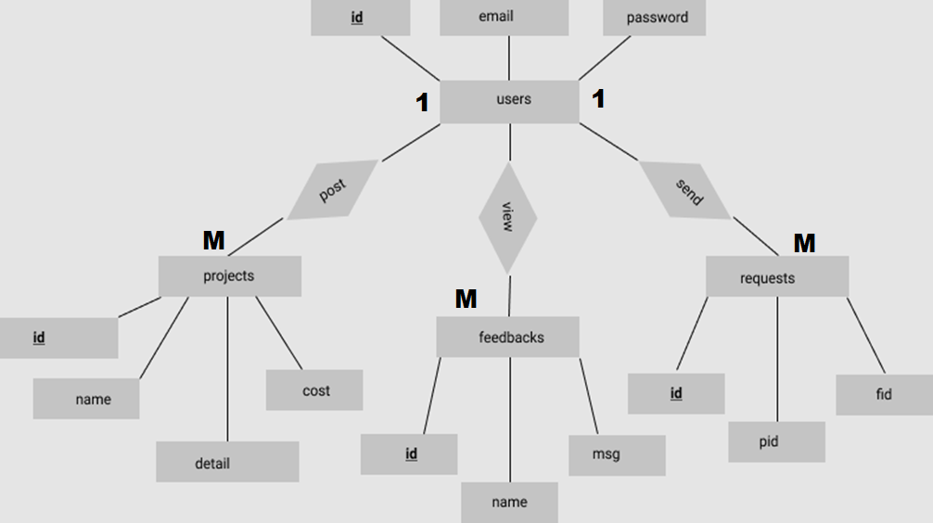

**5.3 UML Diagrams**

**5.3.1 USE CASE DIAGRAM**

**ADMIN:-**

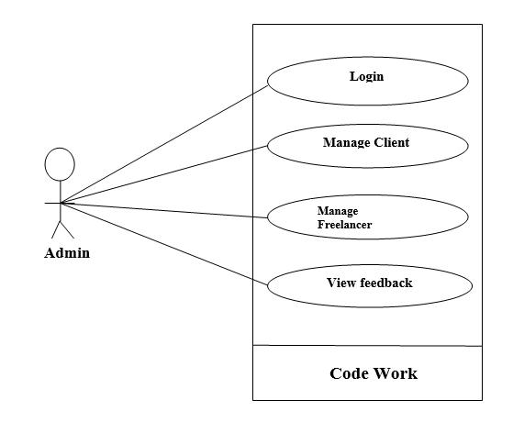

**USER-CLIENT:-**

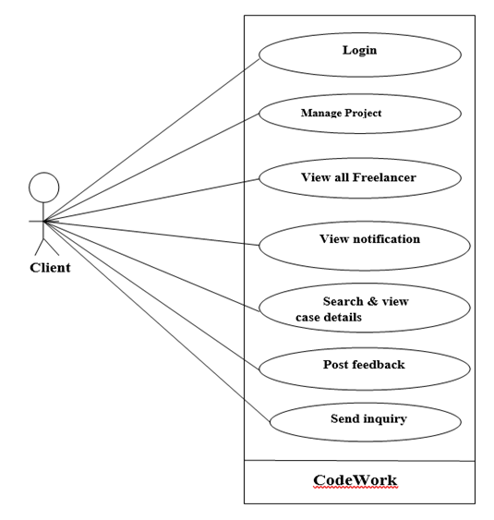

**USER-FREELANCER:-**

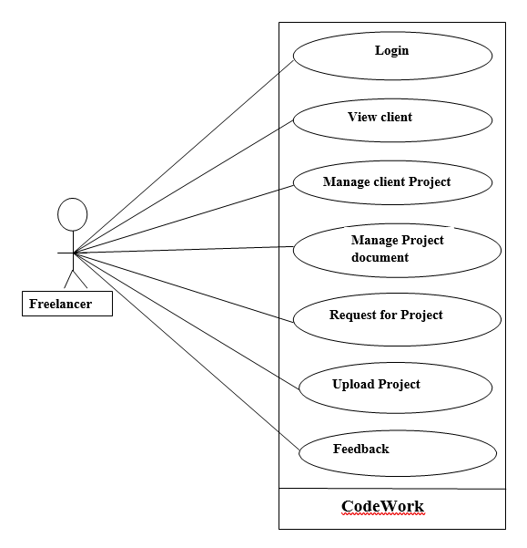

**5.3.2 CLASS DIAGRAM**

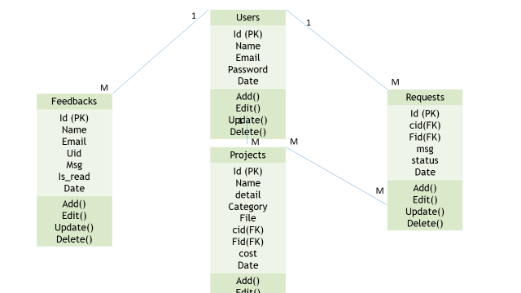

**5.3.3 SEQUENCE DIAGRAM**

**Admin:-**

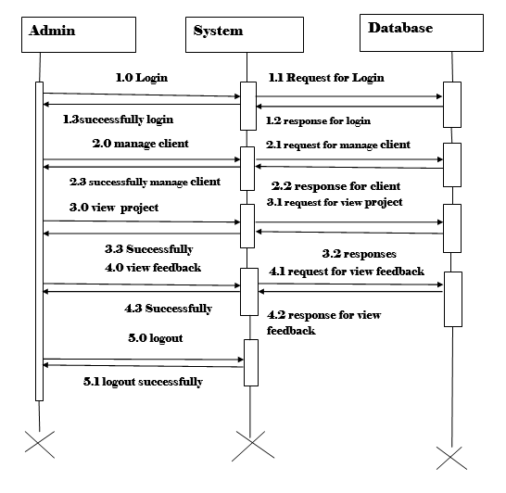

**Client:-**

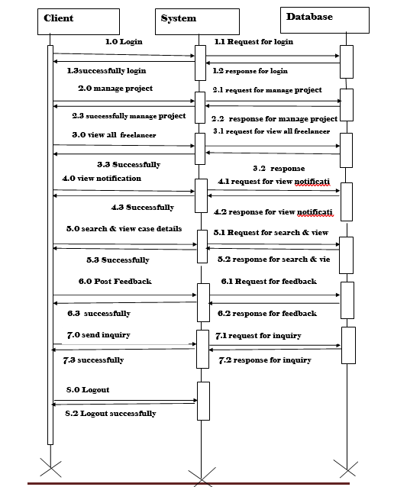

**Freelancer:**

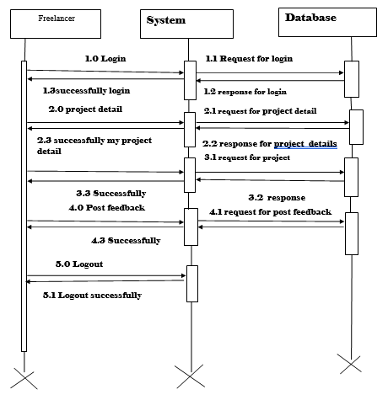

**5.3.4 ACTIVITY DIAGRAM**

**Admin :-**

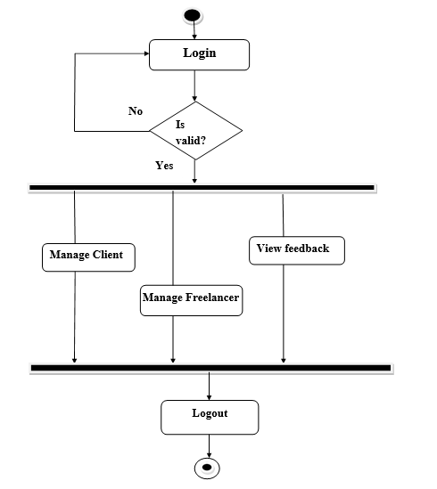

**Client :-**

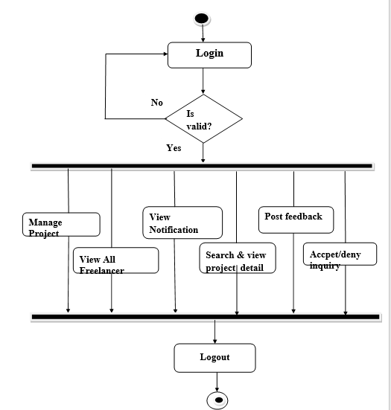

**Freelancer:-**

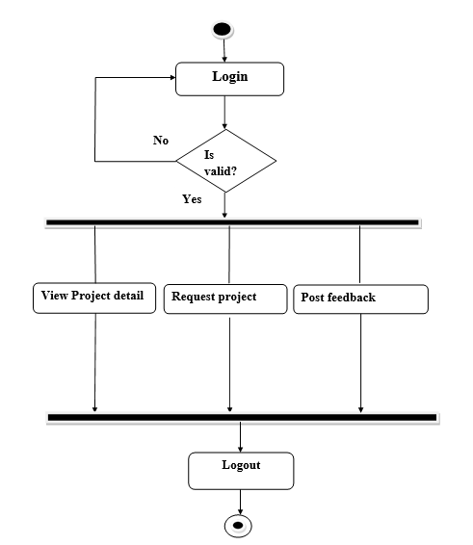

**6. Input & Output Designing**

**6.1 Admin Side Design**

**Login page:- this page is admin login page**

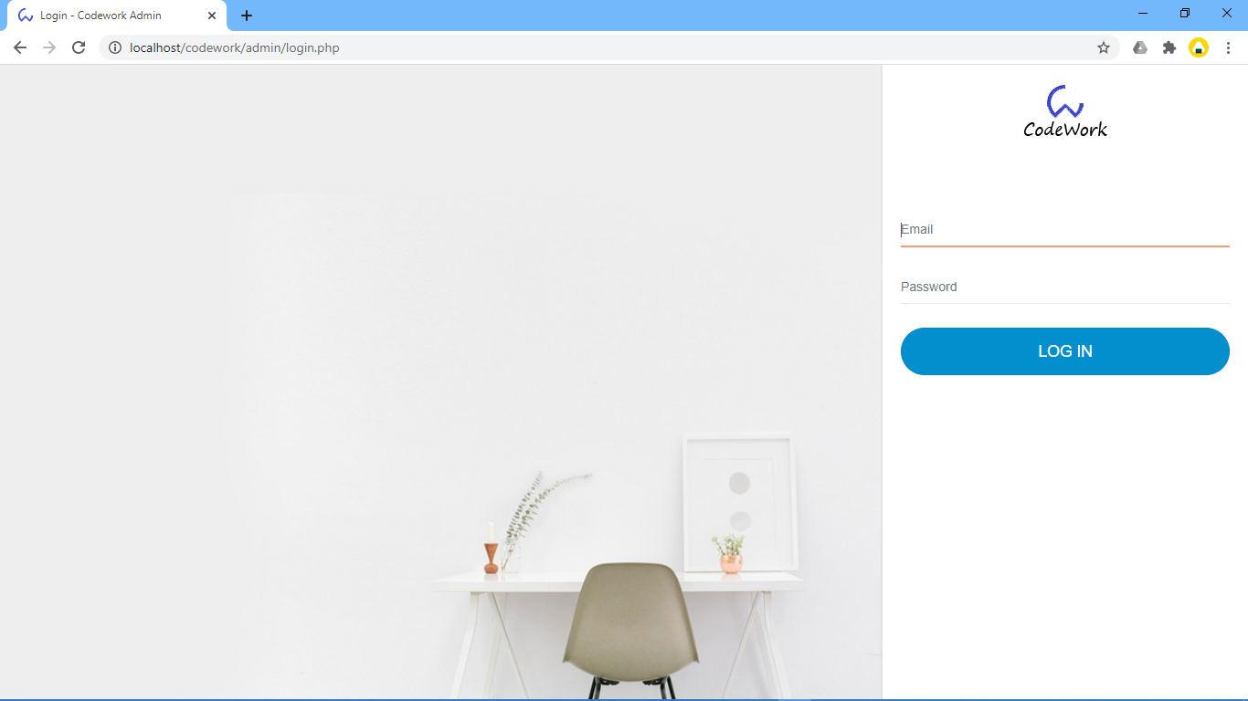

**Admin home page: -**

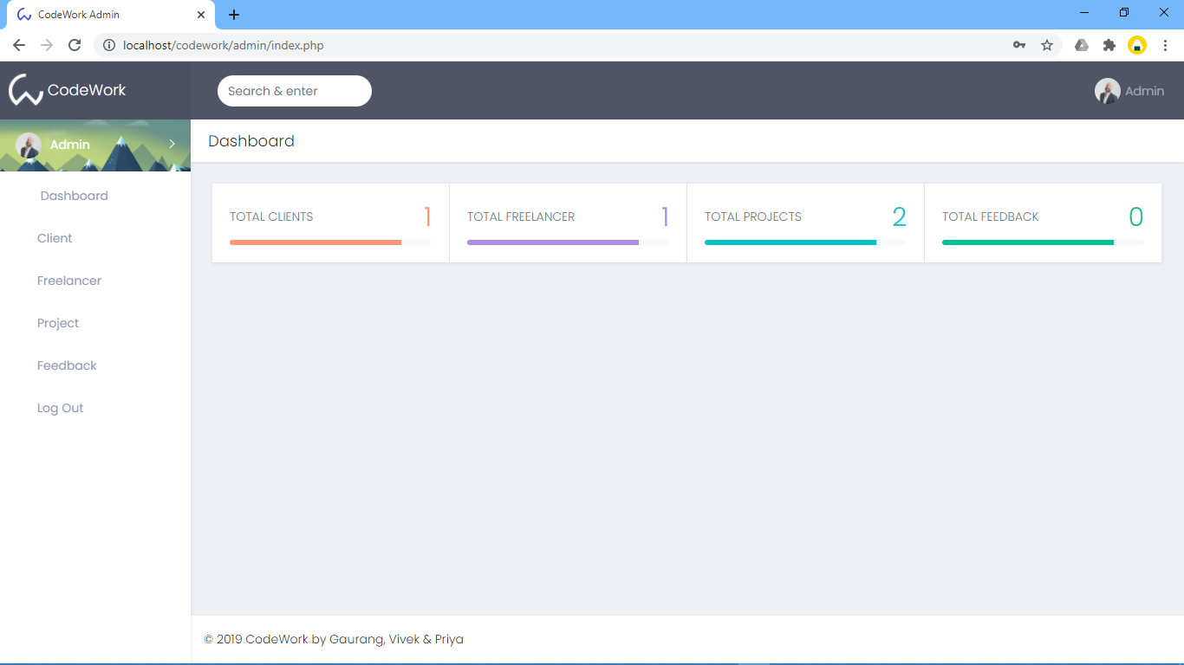

**Admin manage client: -**

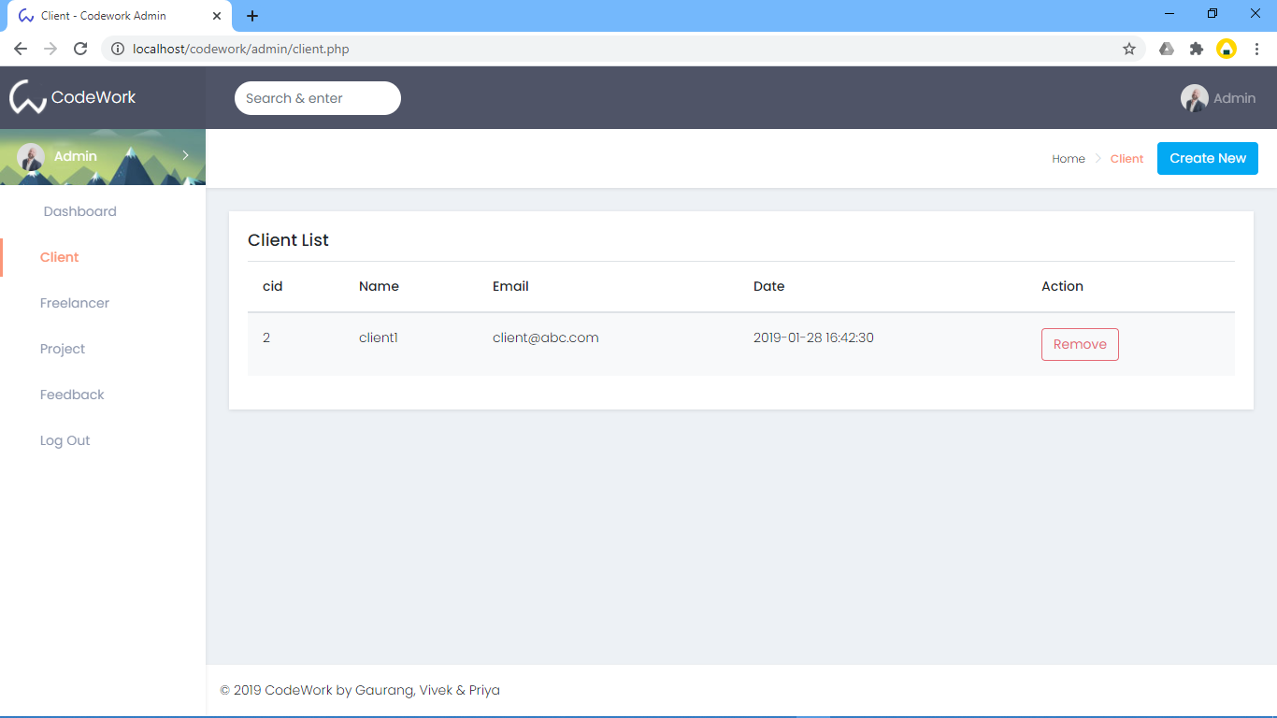

**Admin manage freelancer: -**

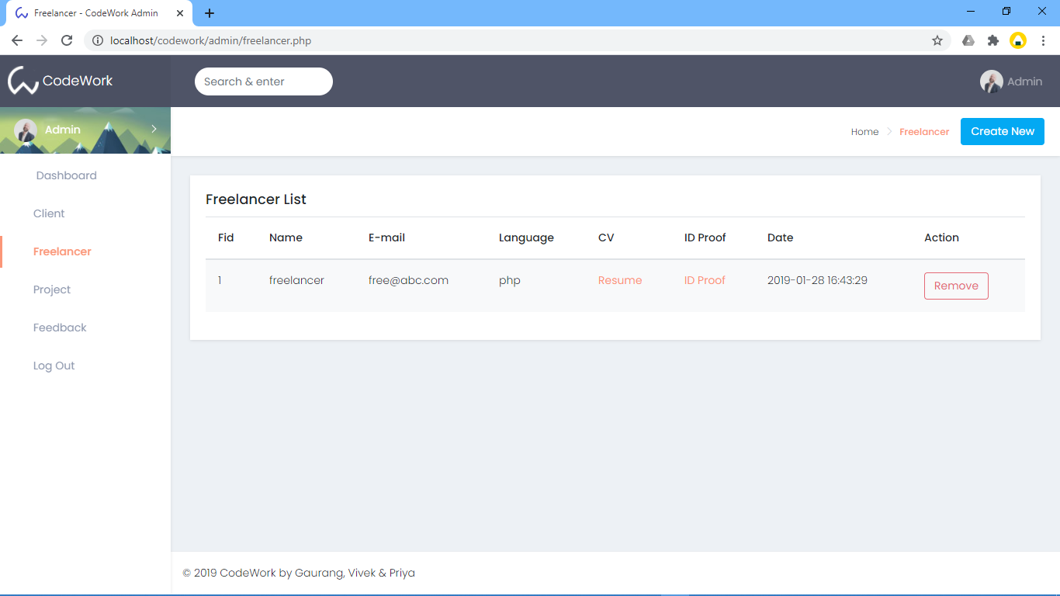

**6.2 User side design**

**User home page: -**

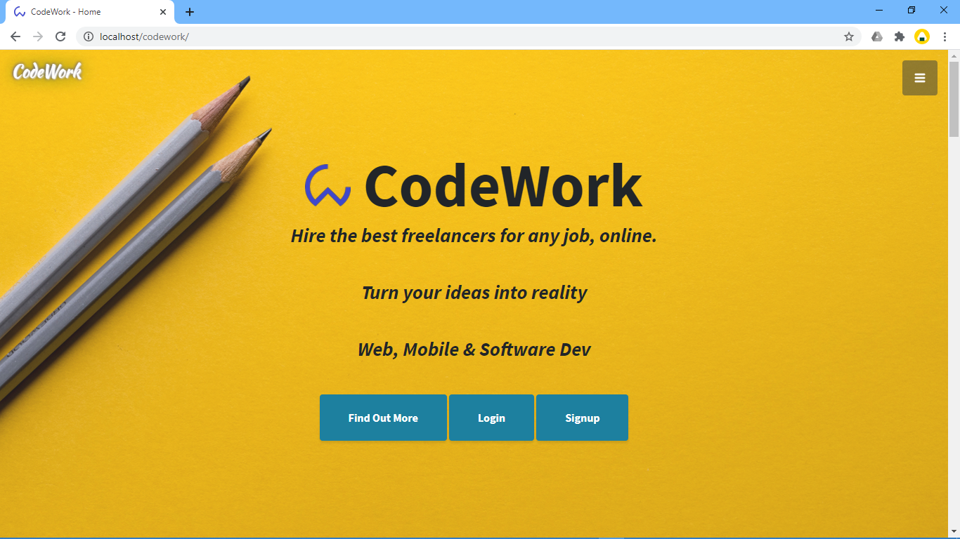

**Service: -**

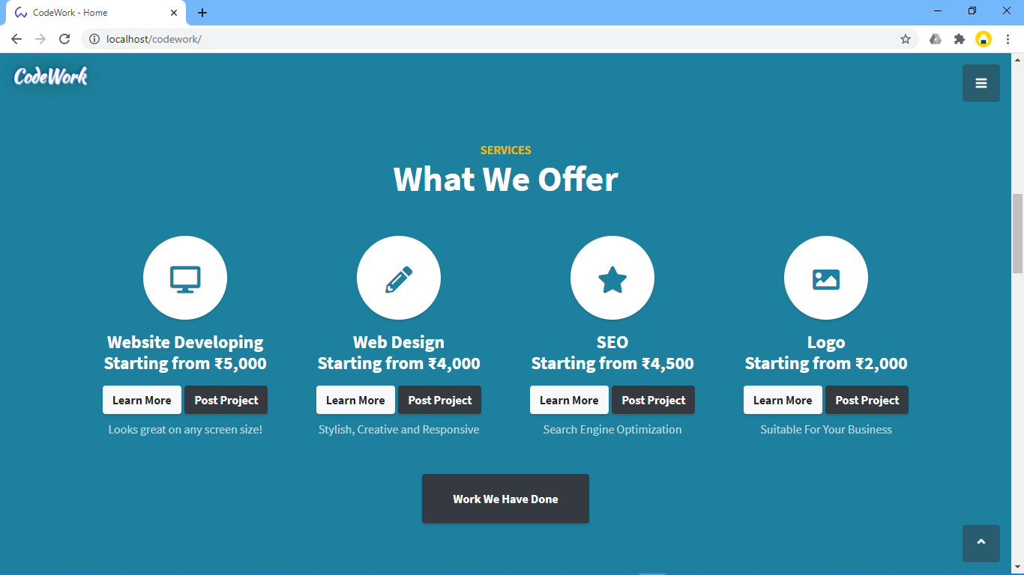

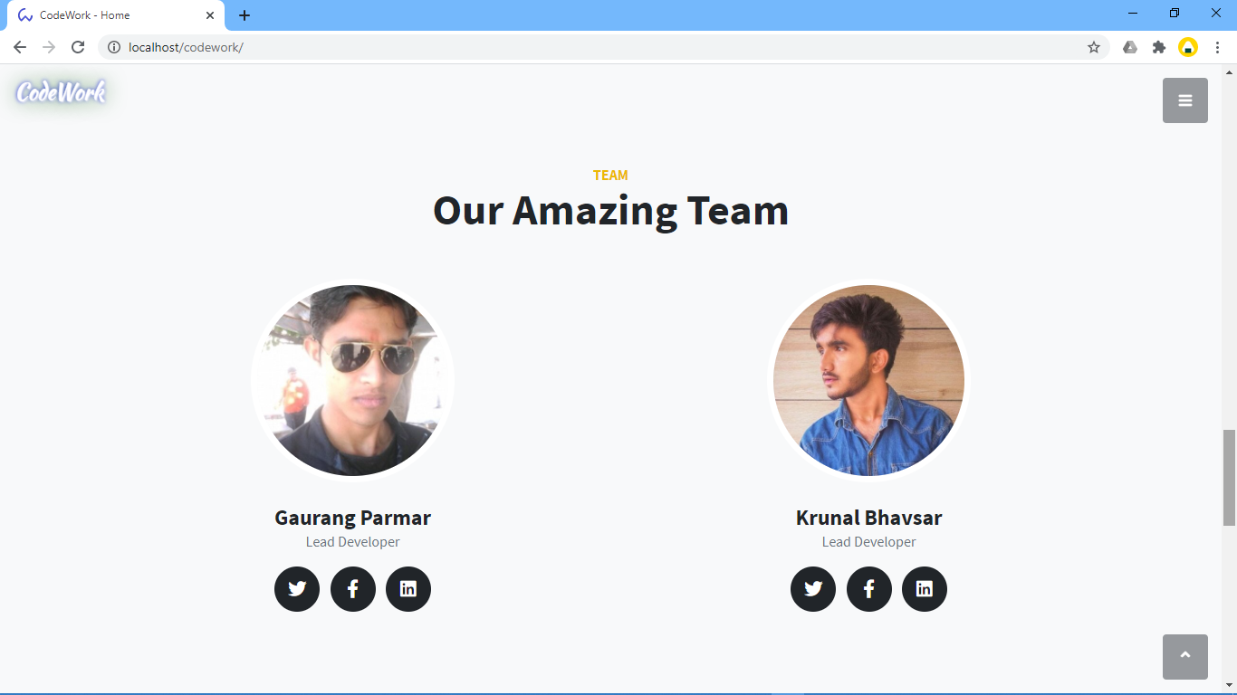

**Feedback :-**

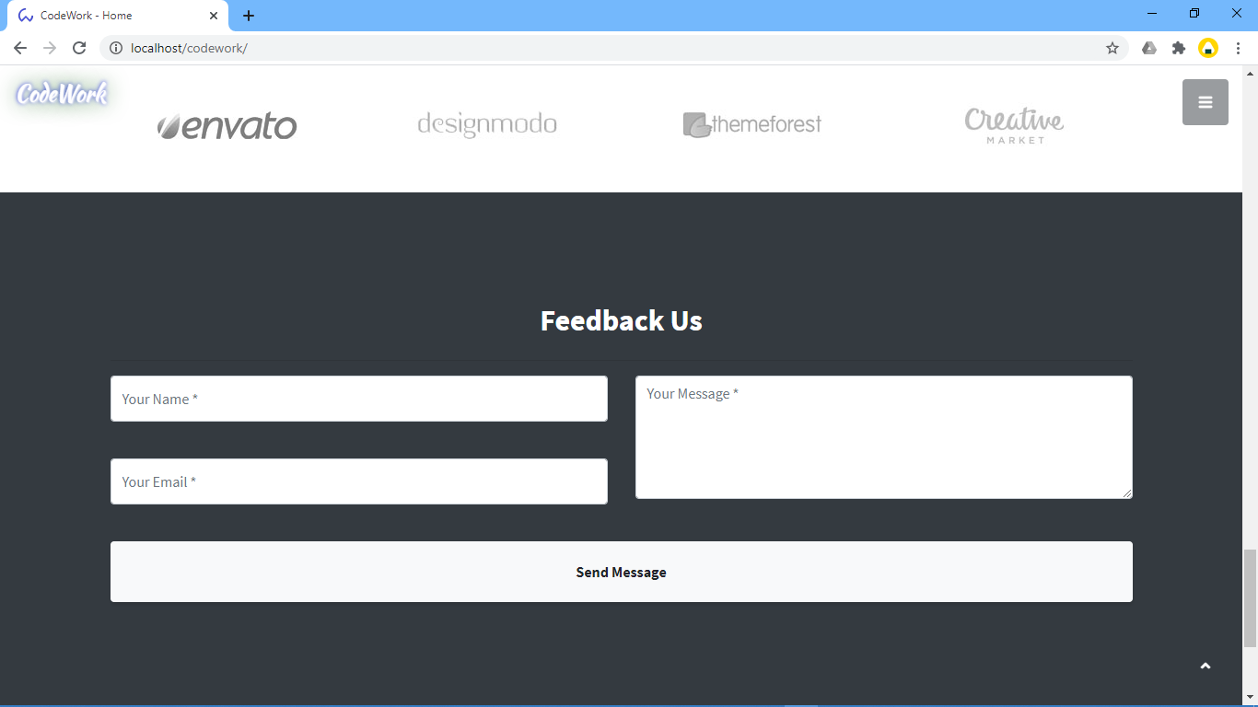

**User login page: -**

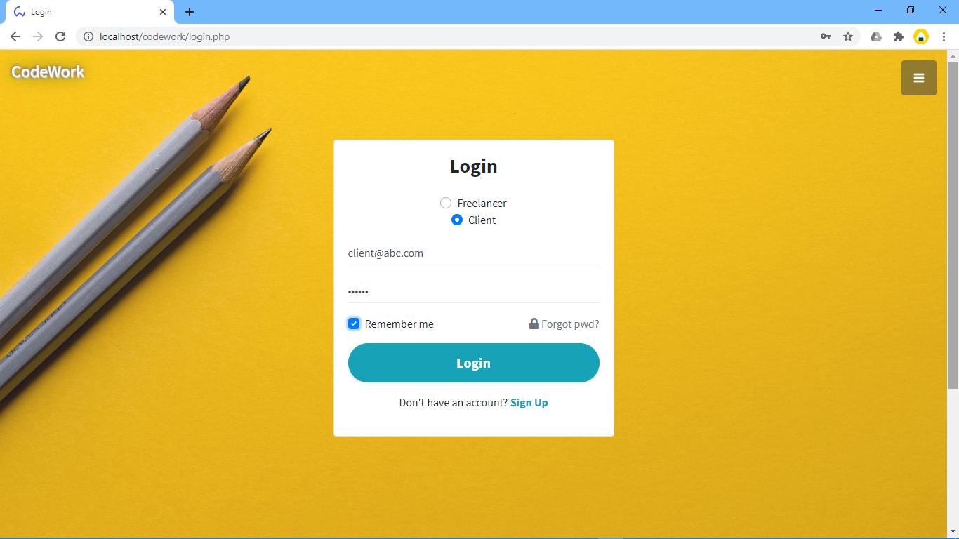

**User signup page: -**

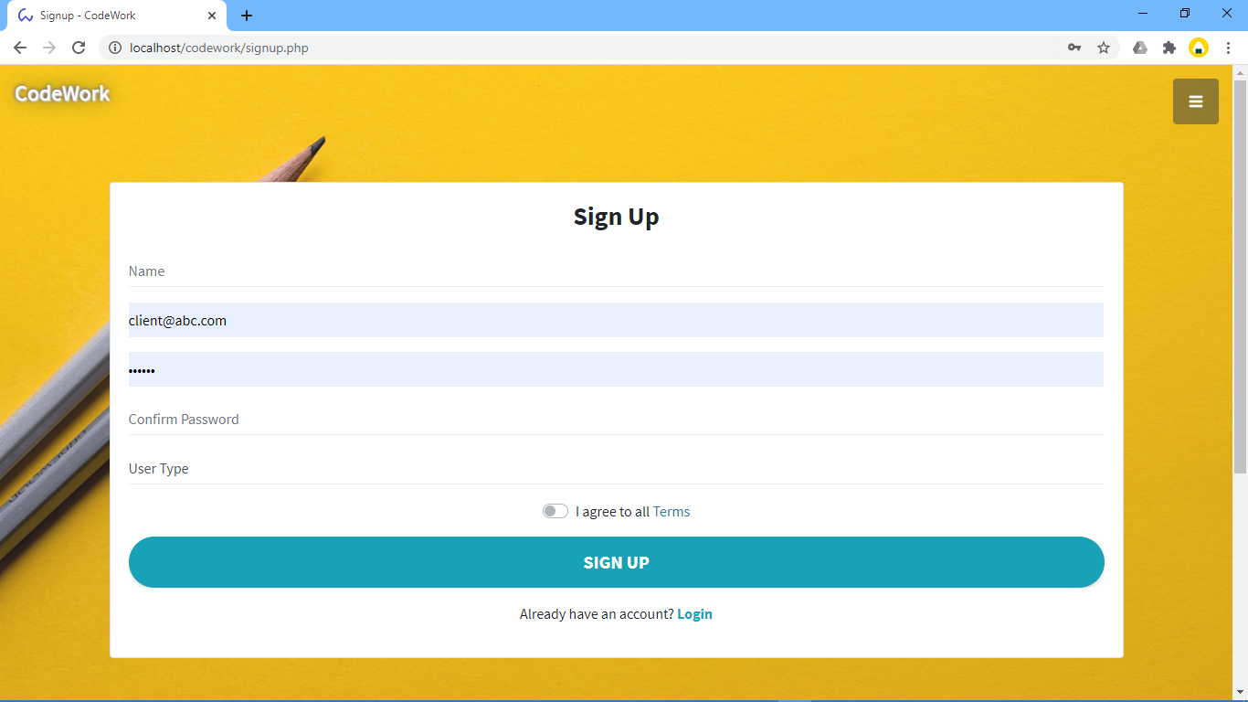

**Client page:-**

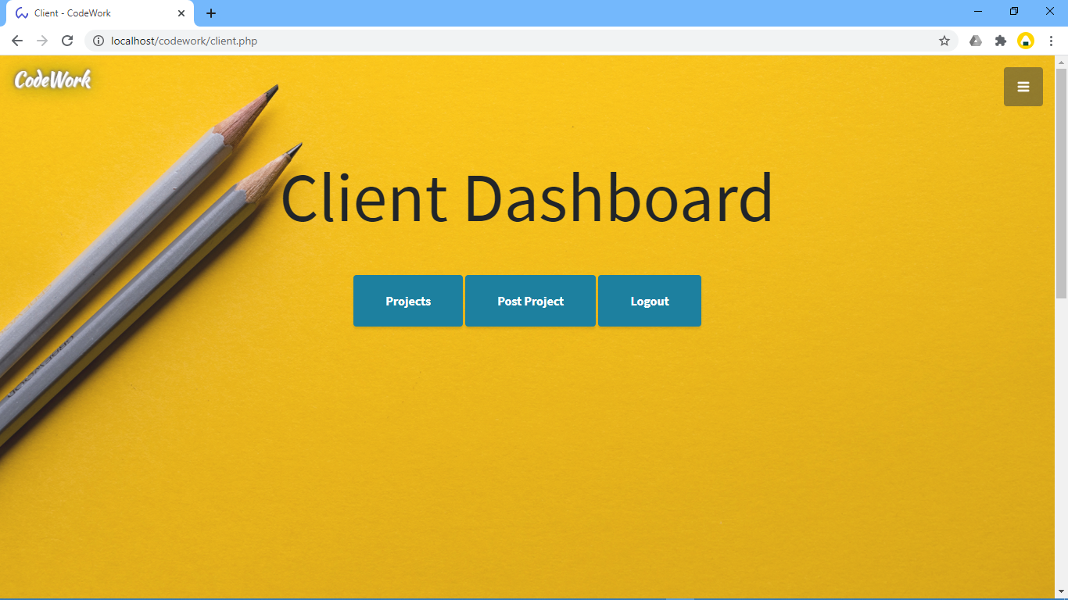

**Post project form:-**

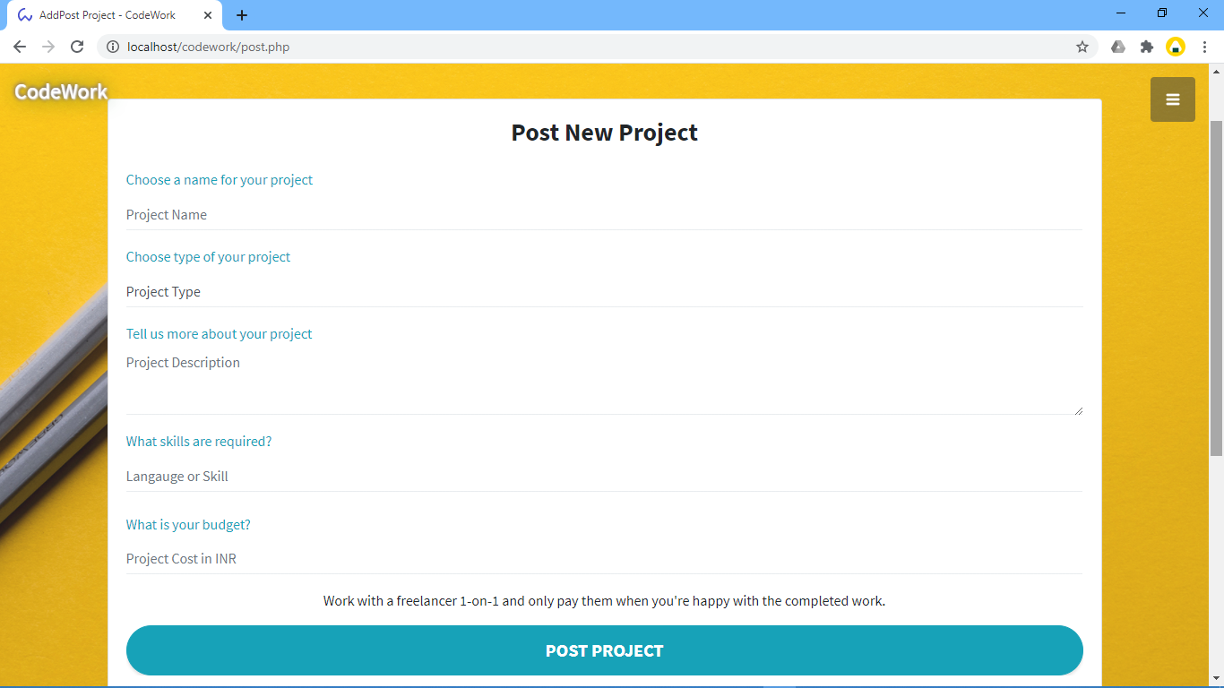

**Project posted by client:-**

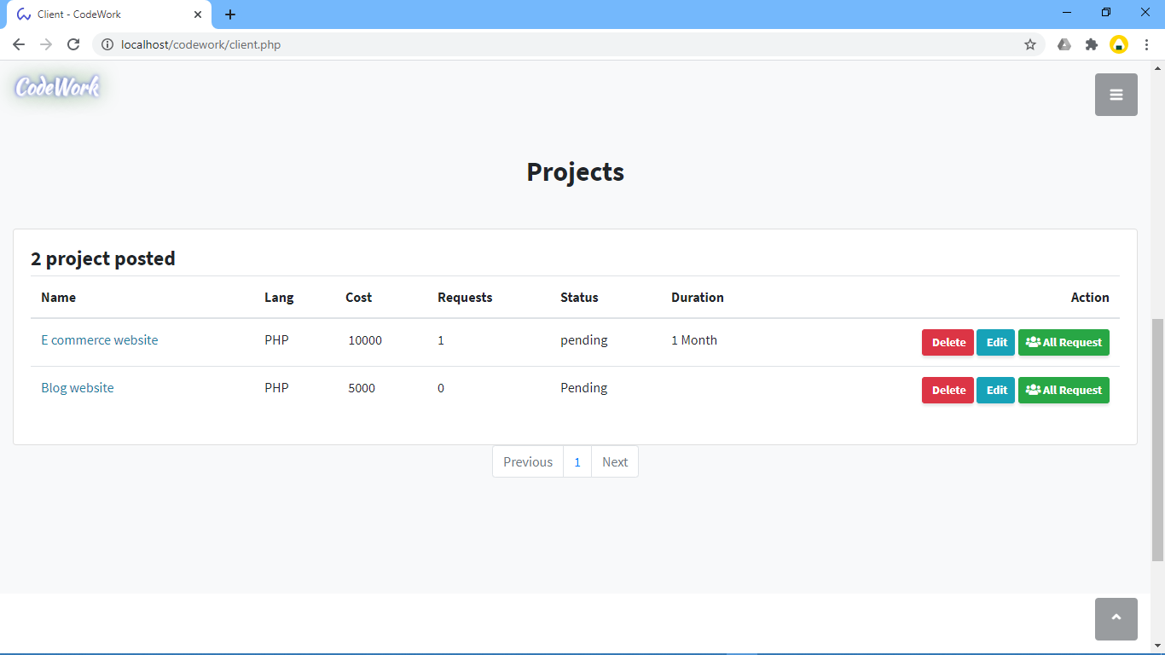

**Freelancer page: -**

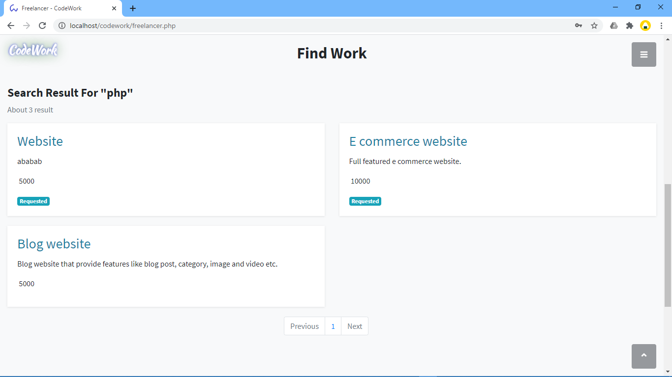

Project details and bidding form: -

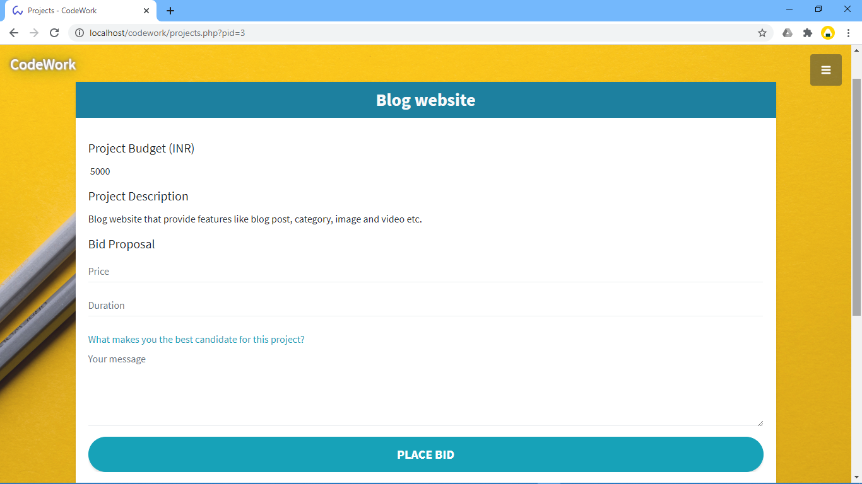

**7.TESTING & RESULT**

**7.1 Introduction**

**TESTING: -**

Testing has a dual function it is used to establish the presence of defects in program and it is used to help judge whether or not the program is usable in practice. Thus, software testing is used for validation and verification, which ensure that software conforms to its specifications and meets the need of the software customer.

We have resorted Alpha testing, which usually comes in after the basic design of the program has been completed. The project scientist will look over the program and the suggestions and ideas to improve or to correct the design. They also report and give ideas to get rid of around any major problems. There is bound to be a number of bugs after a problem have been created.

**7.2 Test Cases**

**Admin Login Form :-**

|  |  |  |  |
| --- | --- | --- | --- |
| SI NO. | Test case | Expected Result | Test Result |
| 1 | Enter valid name and password & click on login button | Display main window | Success |
| 2 | Enter invalid name and password & click on login button | Does not display main window and show the error | Success |

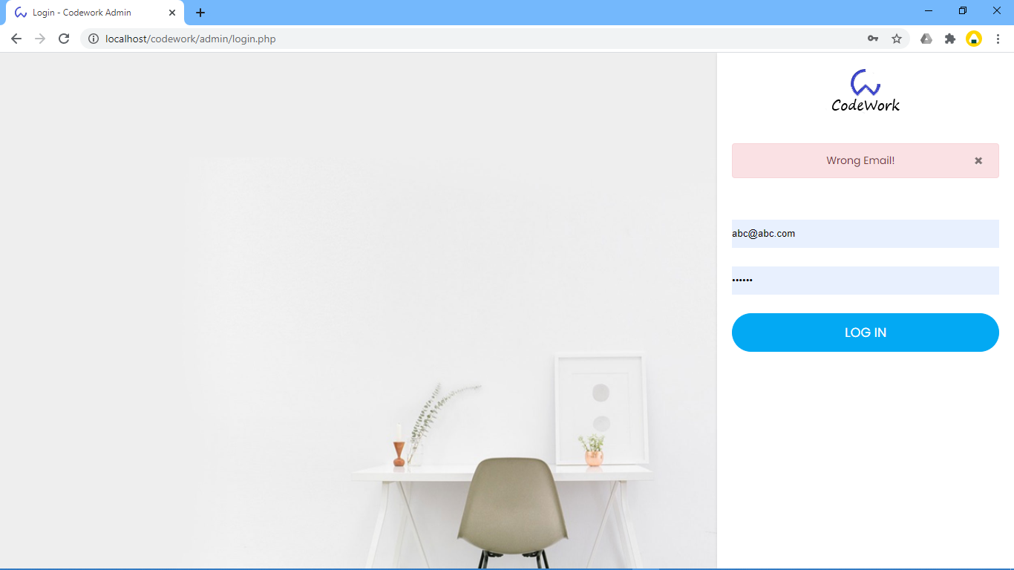

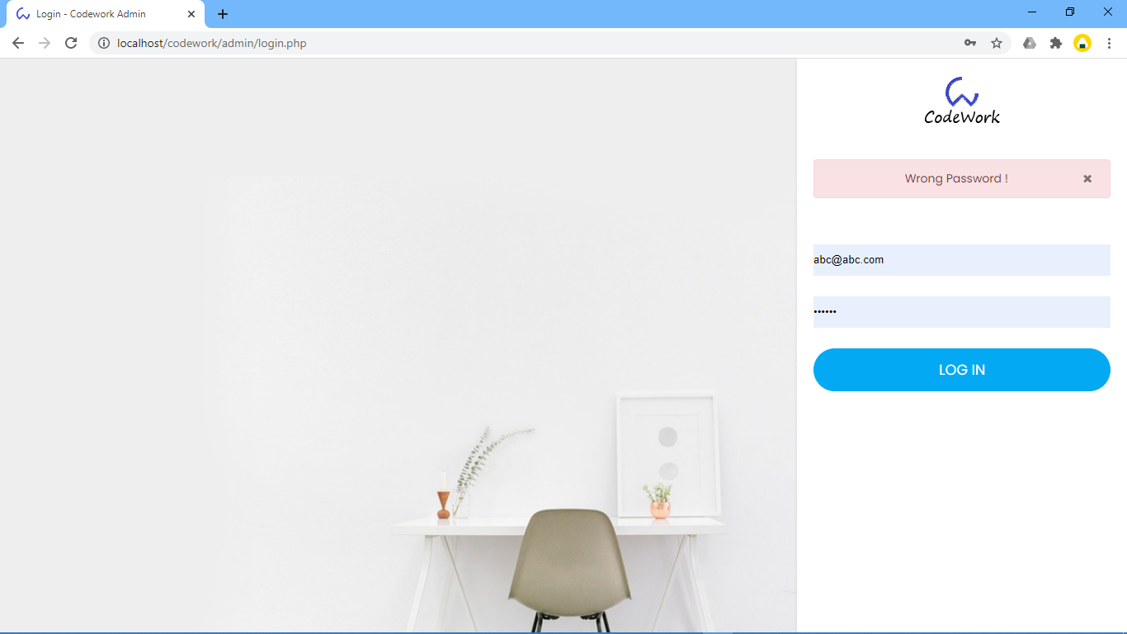

**User login form: -**

|  |  |  |  |
| --- | --- | --- | --- |
| SI NO. | Test case | Expected Result | Test Result |
| 1 | Enter valid name and password & click on login button | User can add/view/request project. | Success |
| 2 | Enter invalid name and password & click on login button | User can not add/view/request project. | Success |

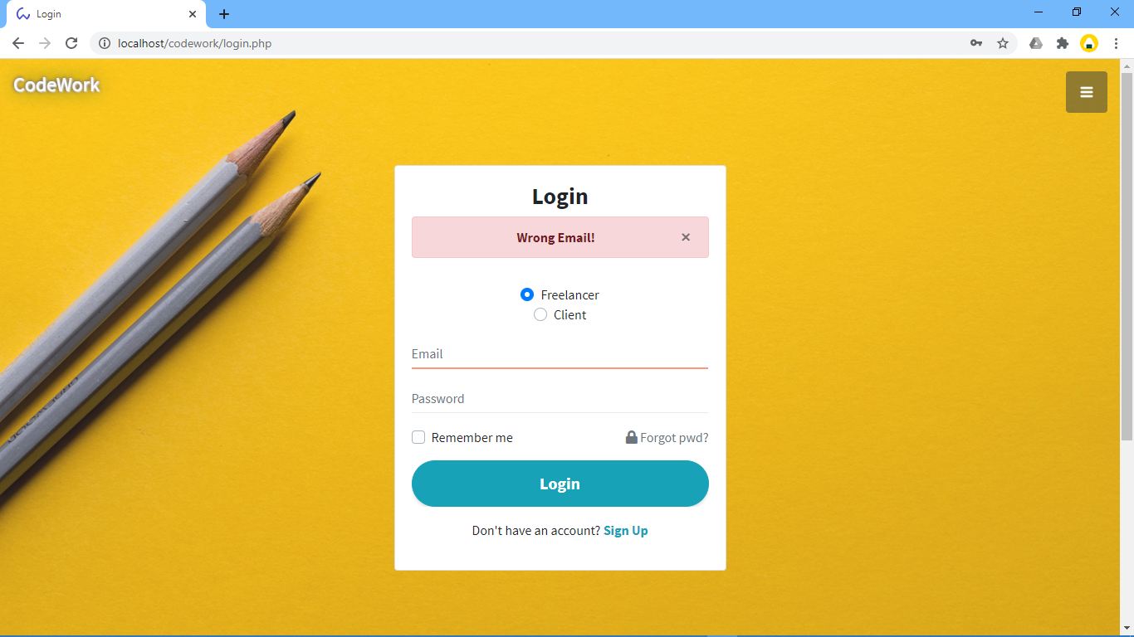

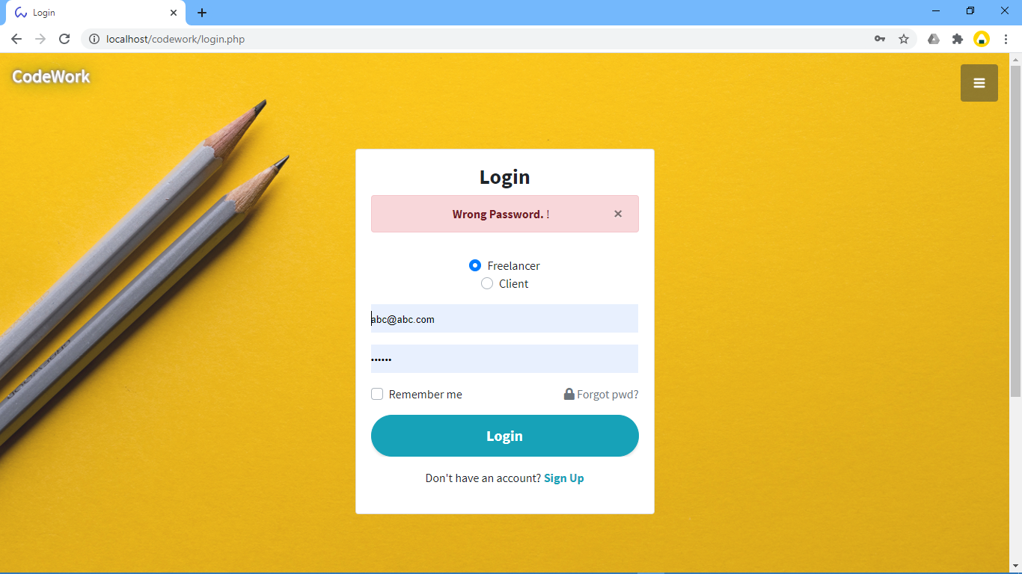

**User post product: -**

|  |  |  |  |
| --- | --- | --- | --- |
| SI NO. | Test case | Expected Result | Test Result |
| 1. | On the click of POST PROJECT button | Add Project | Success |

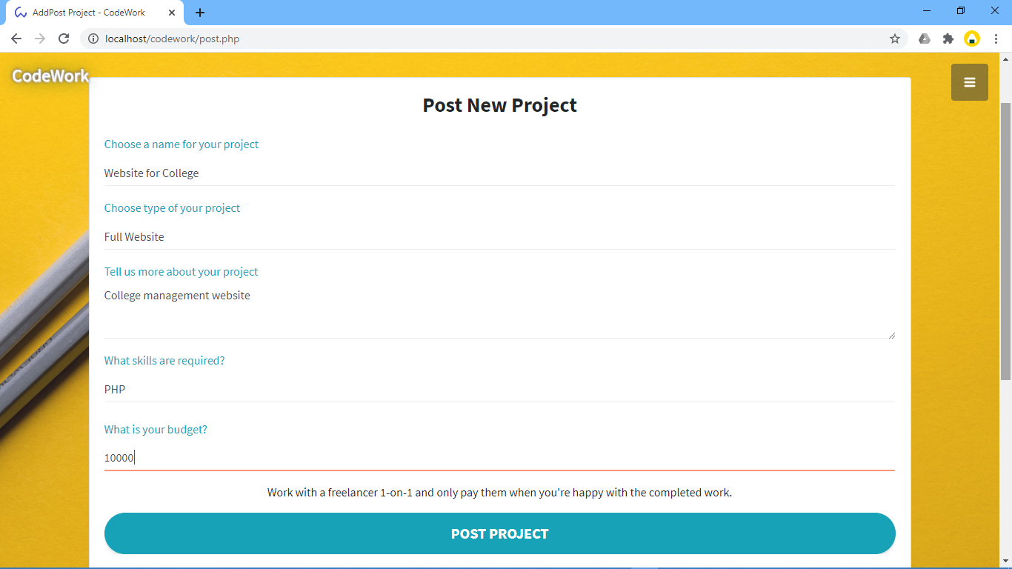

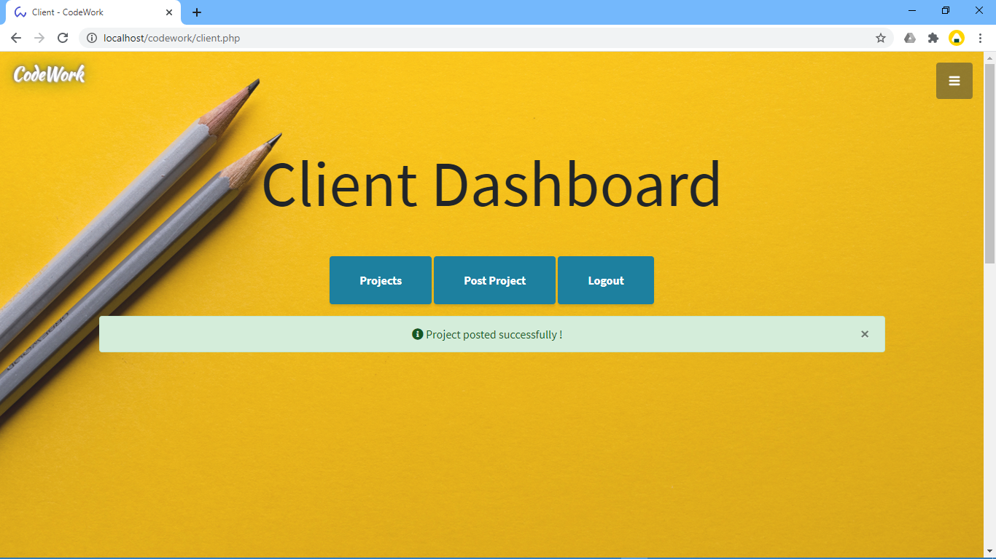

**User can view Request for project: -**

|  |  |  |  |
| --- | --- | --- | --- |
| SI NO. | Test case | Expected Result | Test Result |
| 1. | On the click on ALL REQUESTS button | Add Project bidding with bid price and project duration can be seen. | Success |

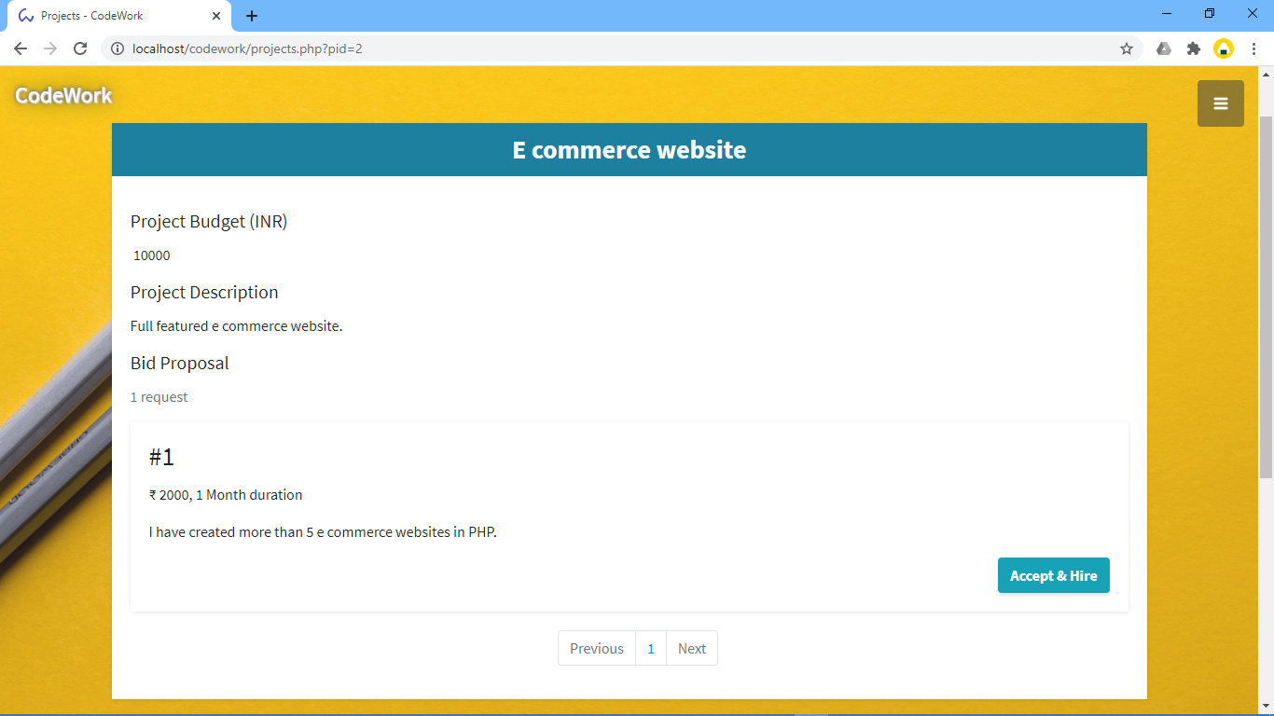

**User request for project: -**

|  |  |  |  |
| --- | --- | --- | --- |
| SI NO. | Test case | Expected Result | Test Result |
| 1. | On the click on PLACE BID button | Project bid price, duration and message will be sent. | Success |

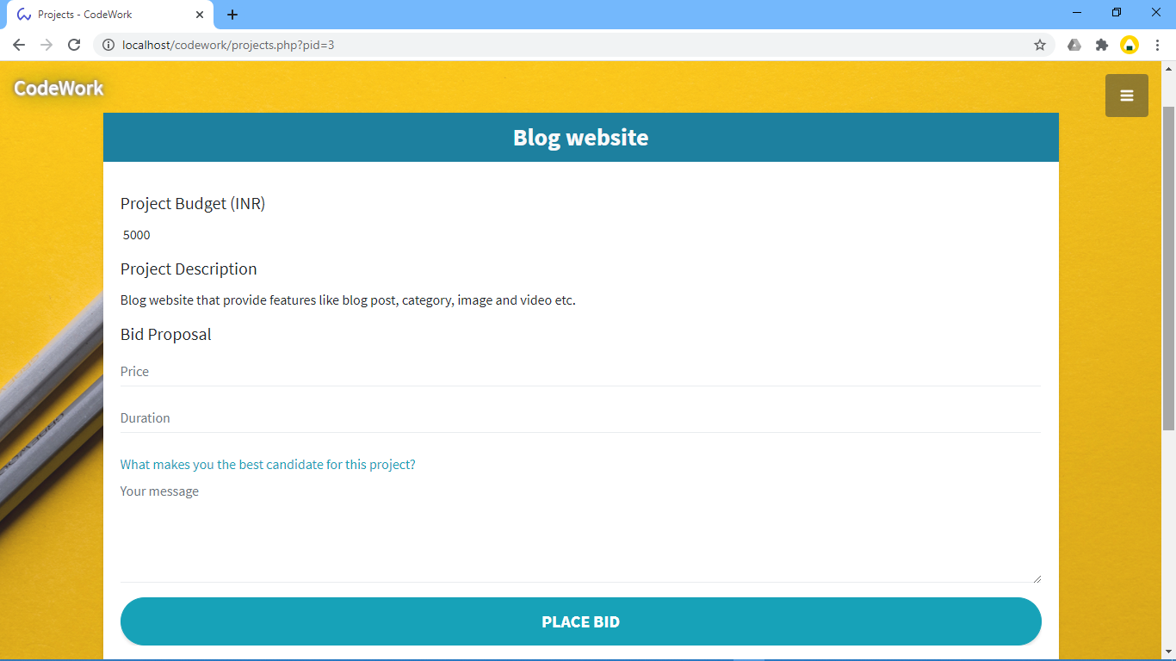

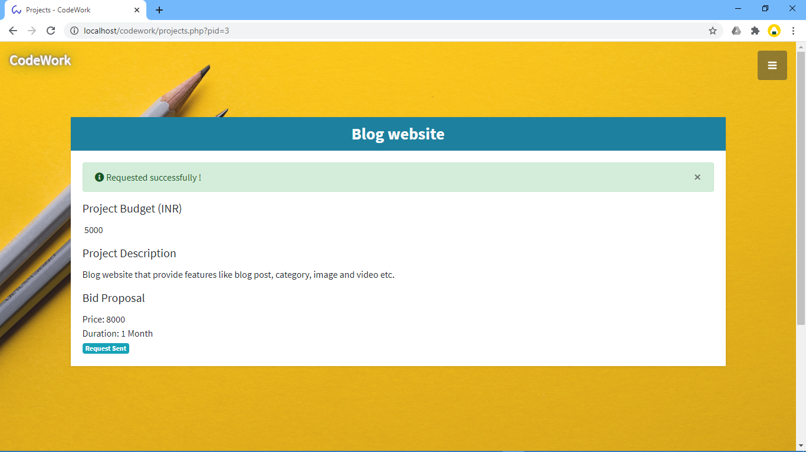

**8. LIMITATIONS & FUTURE SCOPE**

**8.1 Limitations**

* Limitation of this web site is available in only India.

**8.2 Future Scope**

* In the future can SMS & Email notification can be implemented in this system.

**9. CONCLUSION**

**The conclusion is that**

* The client gets their work easily done.
* Clients can choice form lots of well skilled freelancer.
* Freelancer get paid on time for their job.
* Freelancer can maintain their portfolio and personal details to get more clients project easily.

**10. REFERENCES**

**Web Sites References**

* <http://www.youtube.com>
* <http://www.tutorialspoint.com>
* <https://php.net/>
* <https://getbootstrap.com/>
* <https://stackoverflow.com/>

